**MEDICINE/DRUGS DATASET ANALYSIS**

**-- Clean data --**

**-- Remove 'mg' from Strength column**

UPDATE medicine_dataset

SET Strength = cast(REMOVE(Strength, ' mg','')AS UNSIGNED);

**-- set Strength column to Integer**

ALTER TABLE medicine_dataset

MODIFY COLUMN Strength INT;

**-- change 'name' column to medicine_name**

ALTER TABLE medicine_dataset

CHANGE COLUMN name medicine_name CHAR (100);

**-- change 'dosage form' column to 'dosage_form'**

ALTER TABLE medicine_dataset

CHANGE COLUMN `dosage form` dosage_form CHAR(100);

**-- 1. Most Common Medicines in Each Category:**

**-- Identify which specific medicines are most frequently listed within each therapeutic category.**

WITH common_medicine as

(SELECT category, medicine_name, count(*) as medi_count

from medicine_dataset

GROUP BY category, medicine_name

),

rank_med AS

(SELECT category,medicine_name, medi_count,

ROW_NUMBER () OVER (PARTITION BY category ORDER BY medi_count DESC) AS `rank`

FROM common_medicine)

SELECT category, medicine_name, medi_count

FROM rank_med

where `rank` = 1;

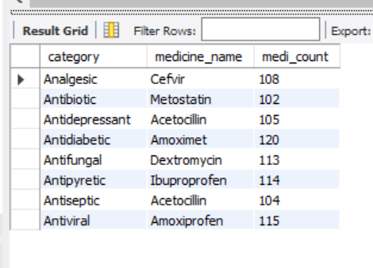

**-- 2. Average Strength by Dosage Form: Determine the average strength of medicines for each dosage form.**

WITH average_med AS

( SELECT dosage_form, avg(strength) AS avg_strength

FROM medicine_dataset

GROUP BY dosage_form

),

rank_avg AS

(SELECT dosage_form, avg_str,

ROW_NUMBER() OVER (PARTITION BY dosage_form ORDER BY avg_str desc) as `rank`

FROM average_med

)

SELECT dosage_form, avg_str

FROM rank_avg

where `rank` = 1;

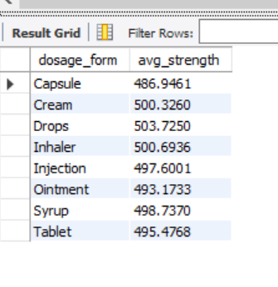

**-- 3. Distribution of Medicines by Manufacturer: Count how many different medicines each manufacturer produces.**

WITH manufacturer AS

( SELECT manufacturer, count(*) as medicine_count

FROM medicine_dataset

GROUP BY manufacturer

),

rank_manufacturer AS

( select manufacturer, medicine_count,

ROW_NUMBER () OVER (PARTITION BY manufacturer ORDER BY medicine_count desc) AS `rank`

FROM manufacturer

)

SELECT manufacturer, medicine_count

FROM rank_manufacturer

where `rank` = 1;

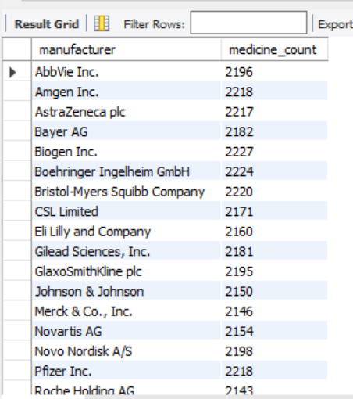

**-- 4. Count of Medicines by Indication: Find out how many medicines are available for each medical indication.**

WITH med_indication AS

(SELECT indication, count(*) as medname_count

FROM medicine_dataset

GROUP BY indication

),

rank_indication AS

( SELECT indication, medname_count,

ROW_NUMBER () OVER (PARTITION BY indication ORDER BY medname_count desc) AS `rank`

FROM med_indication

)

SELECT indication, medname_count

FROM rank_indication

WHERE `rank` = 1;

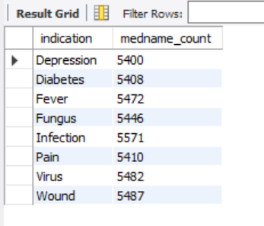

**-- 5. Prescription vs. Over-the-Counter Medicines by Category:**

**-- Compare the number of prescription and over-the-counter medicines within each therapeutic category.**

WITH med_classification AS

(select classification, count(*) as medname_count

FROM medicine_dataset

GROUP BY classification

),

rank_classification AS

(SELECT classification, medname_count,

ROW_NUMBER() OVER (PARTITION BY classification ORDER BY medname_count desc) AS `rank`

FROM med_classification

)

SELECT classification, medname_count

FROM rank_classification

WHERE `rank` = 1;

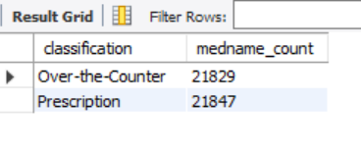

**-- 6. Top Manufacturers for Specific Indications:**

**-- Identify which manufacturers produce the most medicines for particular medical conditions.**

WITH manu_indication AS

(SELECT indication, manufacturer, count(*) AS medname_count

FROM medicine_dataset

GROUP BY indication, manufacturer

),

rank_manu_indication AS

(SELECT indication, manufacturer, medname_count,

ROW_NUMBER() OVER (PARTITION BY indication ORDER BY medname_count desc) as `rank`

FROM manu_indication

)

SELECT indication, manufacturer, medname_count

FROM rank_manu_indication

WHERE `rank` = 1;

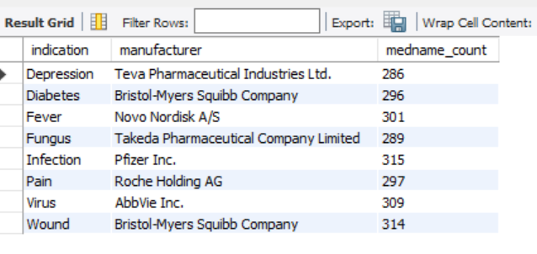

**-- 7. Strength Range for Each Dosage Form: Determine the range of strengths available for each dosage form.**

SELECT dosage_form, min(Strength), max(strength)

FROM medicine_dataset

GROUP BY dosage_form;

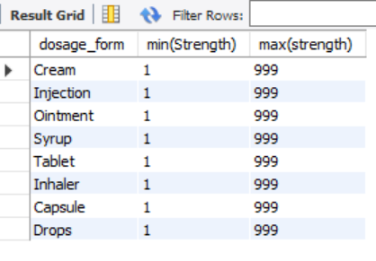

**-- 8. Medicines with the Highest and Lowest Strengths: Identify which medicines have the highest and lowest strengths.**

**-- Lowest**

SELECT medicine_name, Strength

FROM medicine_dataset

WHERE Strength = (SELECT min(Strength) FROM medicine_dataset);

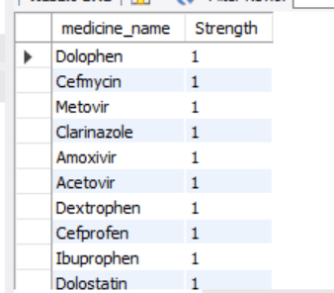

**-- Highest**

SELECT medicime_name, Strength

FROM medicine_dataset

WHERE Strength = (SELECT max(Strength) FROM medicine_dataset);

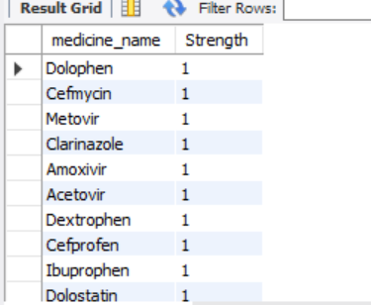

**-- 9. Most Common Dosage Forms for Specific Categories:**

**-- Find out which dosage forms are most commonly associated with each therapeutic category.**

WITH dosage_category AS

(SELECT dosage_form, category, count(*) AS dosage_count

FROM medicine_dataset

GROUP BY dosage_form, category

),

rank_dosage_category AS

(SELECT dosage_form, category, dosage_count,

ROW_NUMBER () OVER (PARTITION BY category ORDER BY dosage_count desc) AS `rank`

FROM dosage_category

)

SELECT category, dosage_form, dosage_count

FROM rank_dosage_category

WHERE `rank` = 1;

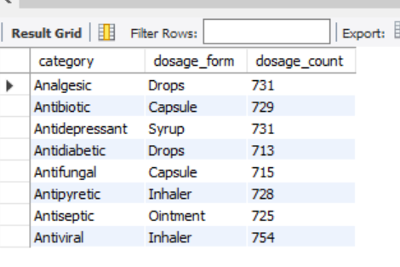

Data Source: https://www.kaggle.com/datasets/ujjwalaggarwal402/medicine-dataset

GitHub Repository: <https://github.com/Florence93/Medicine-Drugs-Data-Analysis>

Author: ©2024 Florence Idowu